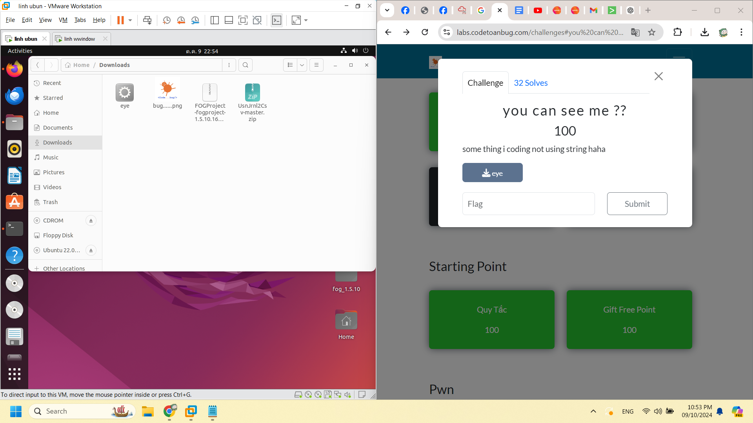

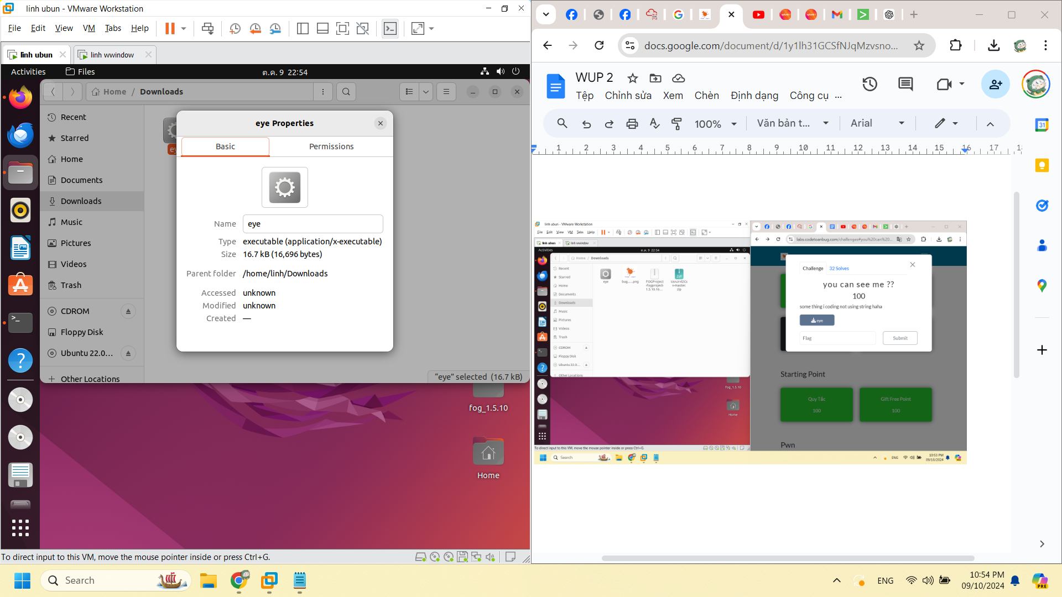

file eye

eye: ELF 64-bit LSB pie executable, x86-64, version 1 (SYSV), dynamically linked, interpreter /lib64/ld-linux-x86-64.so.2, BuildID[sha1]=58f4dd47ab5e5c6c56111d05743b6fb3dc106d9a, for GNU/Linux 3.2.0, not stripped

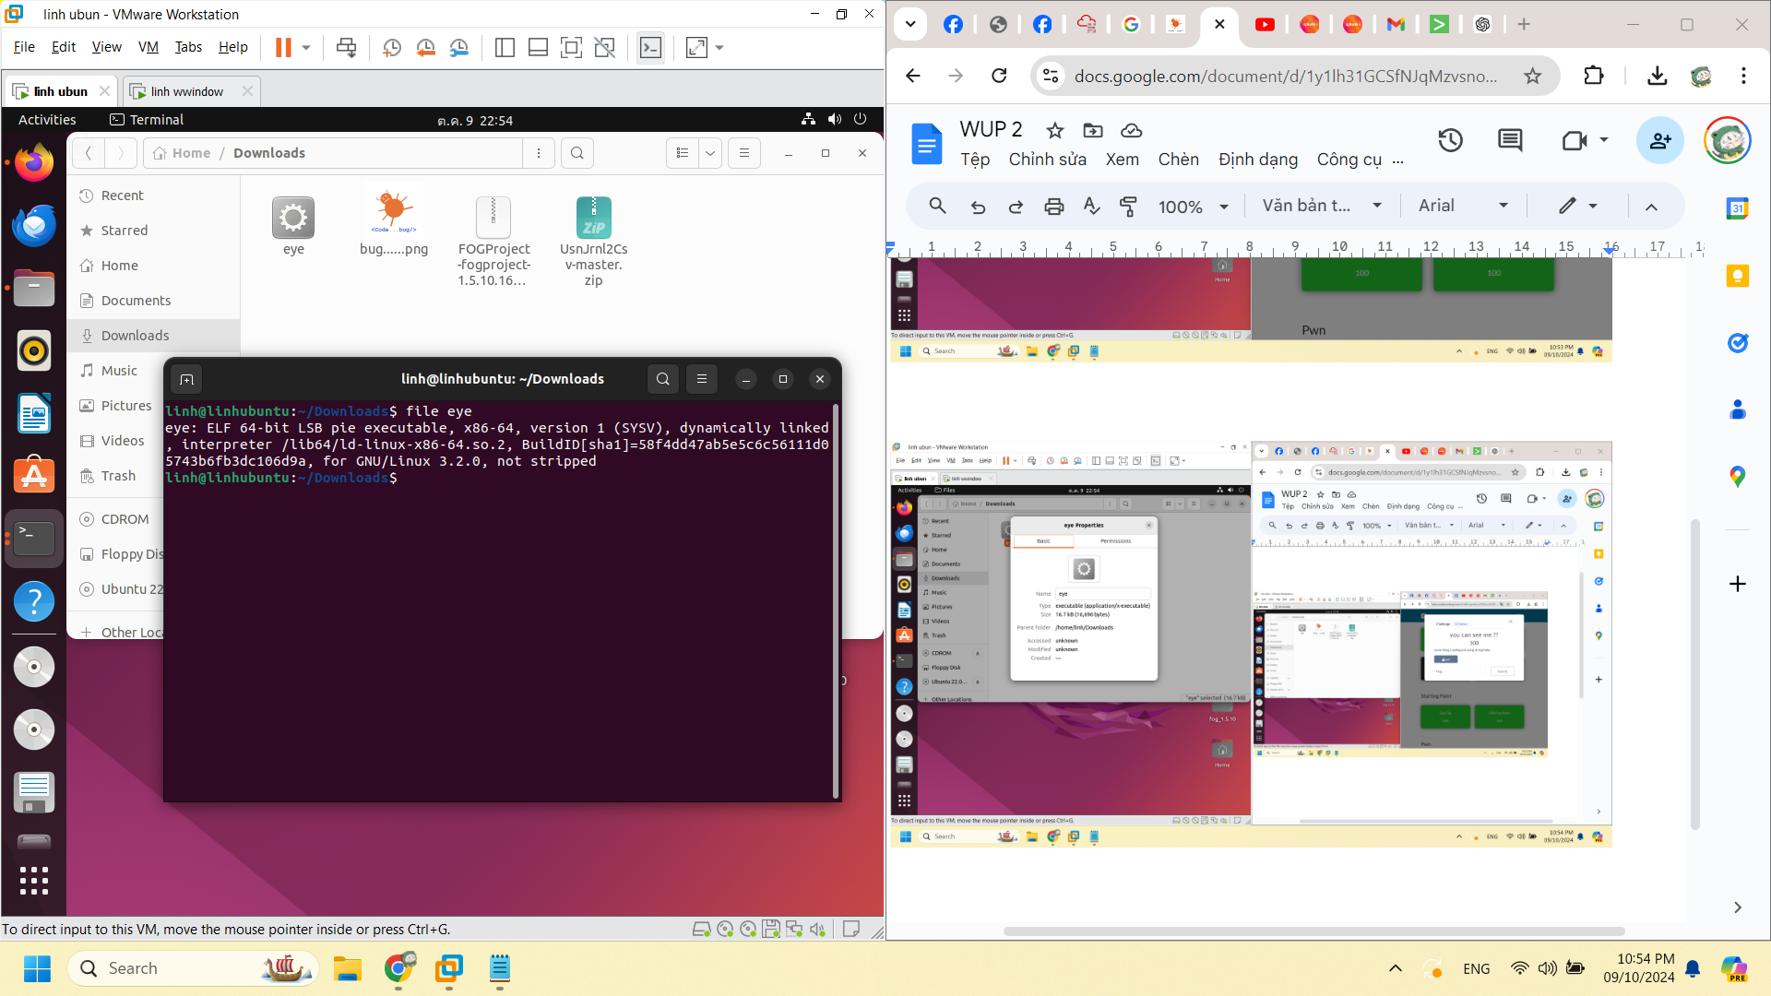

strings eye

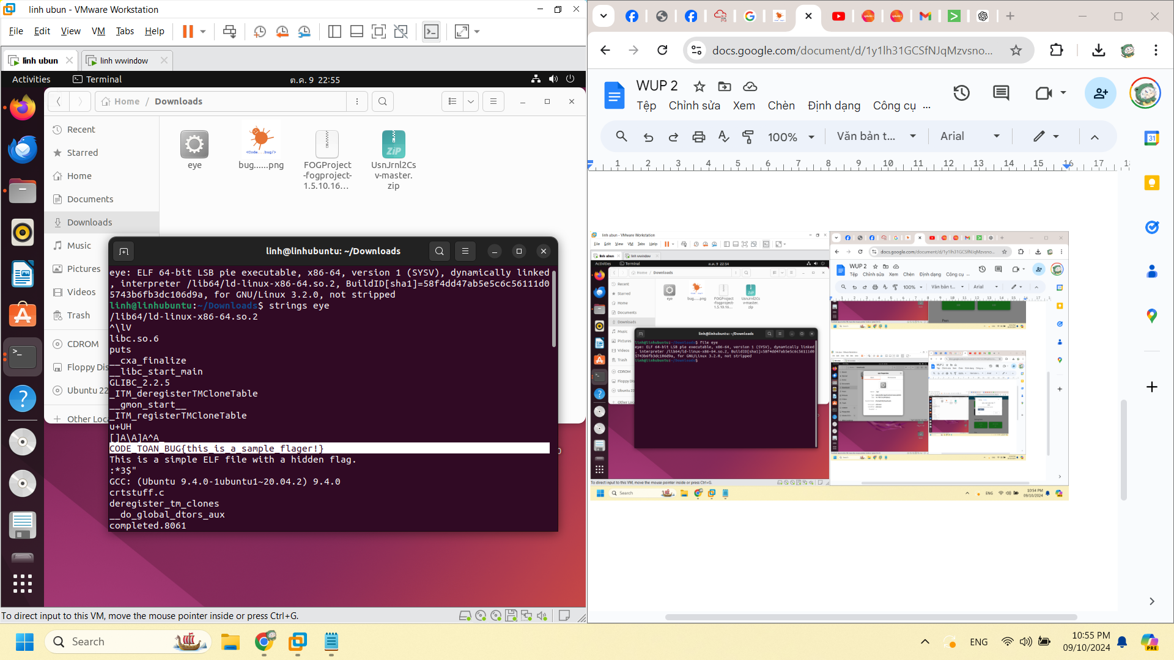

strings eye | grep "CODE_TOAN_BUG"

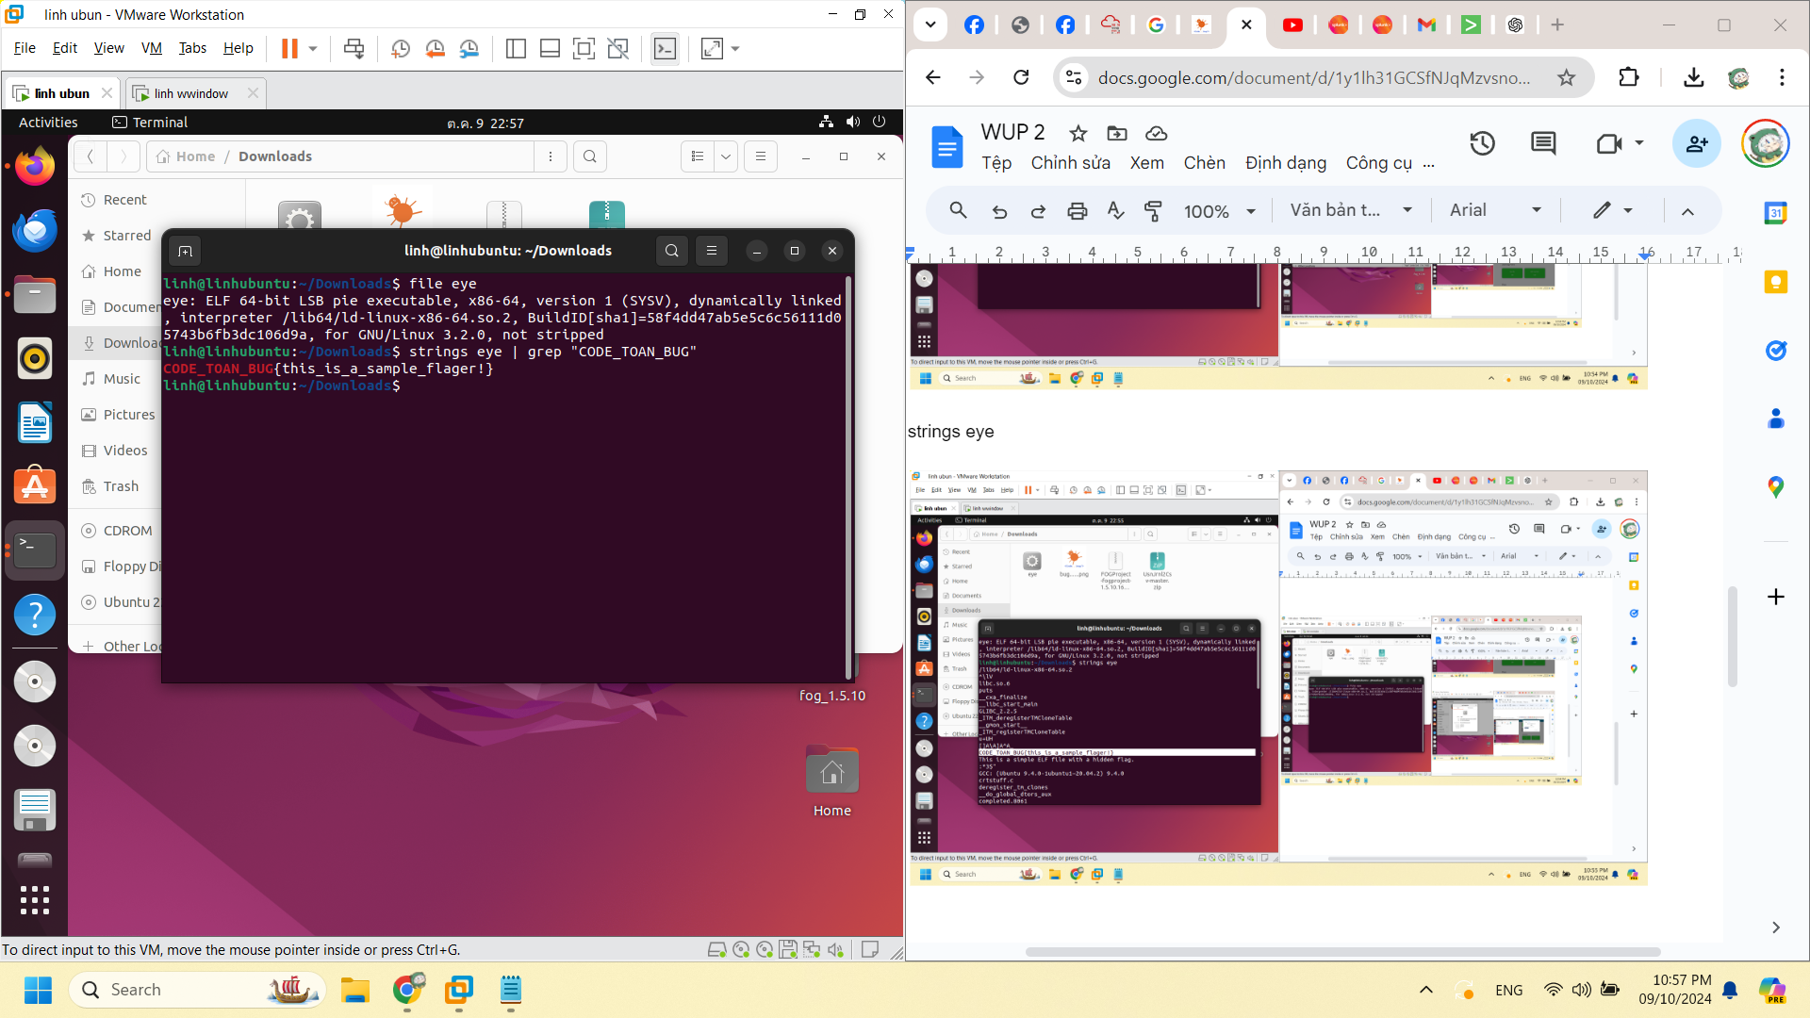

CODE_TOAN_BUG{this_is_a_sample_flager!}

